OVANA ASC Monthly Meeting
Date: February 1, 2026
-Chair opened the meeting @ 2p with the Serenity Prayer.
-Chair asked if there are any inexperienced GSR’s or Visitors. No new GSR’s or Visitors
-Chair asked someone to read 12 Traditions: Yolanda C. 12 Concepts: Joy F. Service Prayer: Lisa B.
Roll Call
Service Position/Homegroup | Present | Absent
Chair – Kristin F |  | *
Vice Chair – Casey H. |  | *
Secretary – Kelly H. | *
Treasurer – Charlie W. | *
RCM – Joy F. | *
RCMA – Open
Literature – Erin W. | *
H&I – Shea B. | *
Activities – Open
Webmaster – Steve O. |  | *
P&P – Open
Public Relations - Open
Clean Connections |  | *
Dope-or-Us |  | *
Home Sweet Home | *
Hope for Us | *
Recovering Minds | *
Release the Control | *
Searching for Serenity |  | *
Spiritual Travelers |  | *
Stepping Up Group | *
Sweet Surrender | *
The Next Right Thing | *
Women’s Power Within | *

Currently 12 home groups in OVANA with voting status. Official Quorum is 6.
There are 8 home groups present today making the 80% modified consensus 6 home groups.
Last month’s minutes read by: Kelly H. Any Corrections: No corrections
Subcommittee Reports
Chair: Absent (Benie B. chaired meeting)
Vice Chair: Absent
Secretary: No report
Treasurer:
January Treasurer Report
● I was able to get added as a member to the bank account and we removed the previous chairperson. The new chairperson was already on the account as she was previous secretary
● I am working with the 2026 OVANA secretary to help her get access to the account as well
● I got a new debit card and updated the debit card on the website host
● I will be working with the subcommittee chairs to build the 2026 budget, they will all need to bring their budgets to February Area
● Cash on hand – $47.36
● PR Remaining balance – $295.05
● H&I KRSCNA Remaining Balance – $79.38 December Statement
See attached bank statement and December Ledger

Literature:
Hello OVANA,

I did not make a literature order in December because we were not in need at the time. I was unable to attend December’s area due to being sick, thank you to Jason who stepped in and helped fill orders. I was not sure at that time what we were low on, so I will be taking care of that today and preparing an order, which will be a big one.
I will also be submitting a proposal from my homegroup later as to how we might use some of the extra money that’s been sitting in the literature account.

Please continue to use the 2023 order for today’s area and we will transition to the 2026 form next month.

Balance: $932.66
Last deposit: $149. 14 on 12/29

See attached for Literature Account Balance.
RCM:
January 2026 RCM report
Hello family.
I attended the regional meeting on January 18TH IN Owensboro. I have not received the revised minutes from the secretary, but I can provide a decent report because I was acting secretary. The regional secretary has the reports from the other areas.
Current balance in treasury is $30,142.32- 6 deposits were made totaling $767.10; 2 withdrawals were made on 11/10/25-$1342.82 to WSC and 11/08/25- Floyd County Token Club $40 for rent on last regional meeting.
CAR is available on NA.org. CAT will be available on 2/3/26. The upcoming world convention for 2028 is in the planning stages. They are looking at a European location of either Portugal, Germany, or Ireland. (It has since been announced that Ireland will host.) Kevin D. reported not having the time or resources to attend the World Service Conference therefore Rodney B. will go in his place. He has agreed to remain in the position and assist with CAR/CAT workshops until the end of his service commitment. He expressed concerns over offering several times to develop a workshop to discuss a policy for KBARNA but has no support for this.
Rodney has registered for the WSC. His expenses for attending the WSC will be submitted in the March regional meeting. He has requested a roommate at the conference in hopes of reducing the region’s expenses. He sent a link for census information that needs to be completed by all area RCMs by 2/28/26. I completed it on 01/19/26. There is a planned CAR/CAT workshop scheduled during the KRCNA convention. The time slot has not been determined.
KRCNA 39 report: Chair was not present, but a report was read by Chris S. The H&H chair resigned, and Season D has agreed to step in. There has been a great turnout for the fundraisers, and everything is going as planned.
KRCNA 40- Louisville area has agreed to host the convention and Larry K. was voted in as convention chair.
RDA service position will be open for nominations beginning in March. This is a wonderful opportunity to see how service is handled in a worldwide view.
A new area has wished to join the region. Hispanic Central Metro Area. This area was formed in September 2025. It has a total of 6 groups. 2 groups in Louisville and 4 in Georgia. There is a convention planned for July 2026, and they are looking for 3 English speaking addicts to help with workshops.
502 area had representation and asked to be readmitted to region. It was granted.
In loving service,
Joy F. RCM
RCMA: Open
H&I: All well, we do have someone that will be going into Sunrise every other Tuesday starting the 17th. Still need trusted servants.
Activities: Open
Webmaster: Absent
P&P: Open
PR: Open
Homegroup Reports
Clean Connections: Absent
Dope-or-Us: Absent
Home Sweet Home: Christina C. will be celebrating 15 years on 2/14. Mark C. will be celebrating 24 years on 2/28. Joel D. will be celebrating 2 years on 3/7.
Hope for Us: Meeting attendance low, could use some support.
Recovering Minds: No report
Release the Control: No report
Searching for Serenity: No report
Spiritual Travelers: Absent
Stepping Up Group: Beth N. will be celebrating 5 years on 2/7. Michelle M. will be celebrating 1 year on 2/7.
Sweet Surrender: Brad B. will be celebrating 10 years on 3/3. Joy F. will be celebrating 24 years on 2/17.
The Next Right Thing: Needs support
Women’s Power Within: No report

Nominations and Elections of New Officers
Open Position | Yes | No | Abstain
RCMA
PR
Activities – Lisa B. | 7 | 0 | 0
P&P
Release the Control nominated Lisa B. to serve as Activities Chair. Lisa B. completed Service Resume, read it, and vote was taken on the floor. Lisa B. was voted in as Activities Chair for 2026. Service resume attached.
The remaining positions listed above are still open and need trusted servants.

Regional Motions
Regional Motion | Yes | No | Abstain
6-1-25 | 6 | 0 | 2
11-1-25 | 6 | 0 | 2
11-2-25 | 6 | 0 | 2

Open Forum:
Joy F. – Our area is supposed to host a Traditions and Concepts workshop in November, will need help putting on that workshop.
Erin W. – Someone has keys to the literature closet/cabinet and will take inventory as they need it. Erin is requesting someone to try to get the keys back, so she can maintain proper inventory, and when a homegroup needs to obtain a Literature order they need to come to area to obtain them. Benie B. stated he would make a call and try to obtain the keys.
Someone brought up about taking a NA meeting inside the Clark County Jail. Informed individual that H&I would oversee contacting the jail and getting that set up.
Old Business
No Old Business
New Business:
Women’s Power Within filled out a proposal form. They propose to allocate extra Literature funds to H&I and PR. $200 in Literature to be held for H&I and $100 to be held for PR. Financial impact: Literature has had several hundred dollars of extra money in their account for many months. Proposal form attached. This will need to go to homegroups for a vote.
Next Area Business Meeting: 2/22/26 @ 2p at Floyd County Token Club.
Close the meeting @ 2:45p with Serenity Prayer

Literature Account Balance attachment
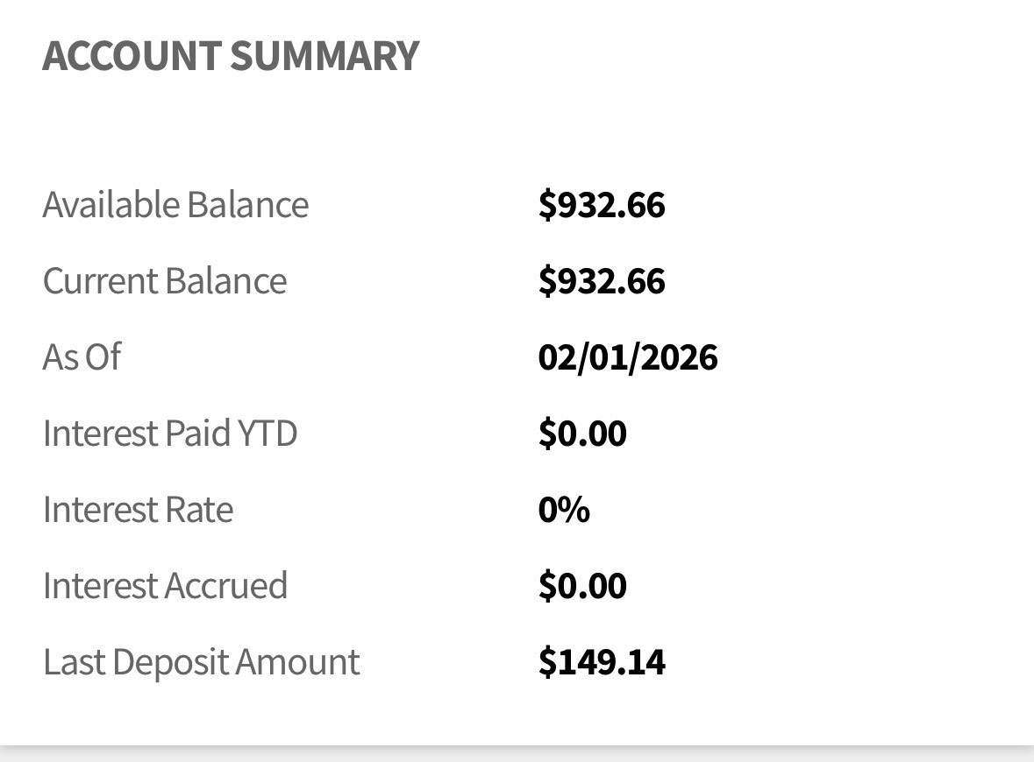

Lisa B. Service Resume attachment
Women’s Power Within Proposal Form attachment
Bank Statement and Ledger

