OVANA ASC Monthly Meeting
Date: June 28, 2026
Chair opened the meeting @ 2p with the Serenity Prayer.
Any inexperienced GSR’s or Visitors: Amanda A.
Reading of 12 Traditions: Christina; 12 Concepts: Lisa; Service Prayer: Shea
Roll Call
Service Position/Homegroup | Present | Absent
Chair – Kristin F | *
Vice Chair – Jason H. | *
Secretary – Kelly H. | *
Treasurer – Charlie W. | *
RCM – Joy F. | *
RCMA – Open
Literature – Erin W. | *
H&I – Shea B. | *
Activities – Lisa B. | *
Webmaster – Steve O. | Report sent
P&P – Open
Public Relations - Open
Clean Connections |  | *
Home Sweet Home | *
Hope for Us | *
Recovering Minds | *
Release the Control | *
Stepping Up Group |  | *
Sweet Surrender | *
The Next Right Thing | *
Women’s Power Within | *
Dope Or Us | *
KCB | 1st Meeting

Currently 10 home groups in OVANA with voting status. Official Quorum is 6.
Last month’s minutes read by: Kelly H. Any Corrections? No Corrections
Motion to accept: Next Right Thing; 2nd: Home Sweet Home
All in Favor: 8 Opposed: 0 Abstain: 0
Subcommittee Reports
Chair: No Report
Vice Chair: No Report
Secretary: No Report
Treasurer: Motion to accept: Hope for Us 2nd: Recovering Minds
All in Favor: 8 Opposed: 0 Abstain: 0
See attached for full report.
Literature: Motion to accept: Hope for Us 2nd: Dope or Us
All in Favor: 8 Opposed: 0 Abstain: 0
See attached for full report
RCM: No Report
RCMA: Open
H&I: Met before area, need more trusted servants to take meetings into institutions.
Activities:
Hello family, our picnic on June 13th was a lot of fun. We had approximately 23 people in attendance. We collected $192.00 from the event. There were 2 newcomers in attendance. Miracle is our next big NA function on August 7th-9th. Please call me for any question, 812-620-3958. Turned in $192.00 from picnic and have $400.00 donation from Home Sweet Home for Miracle specifically. Requesting $608.00 to total $1,200.00 for the event. Yours in service Lisa B.
Webmaster:
Hello Family-i am traveling this weekend and will not be at Area. The website is running fine, May Minutes have been uploaded although I was a bit late getting them posting. I apologize and will do better moving forward. Please continue to send schedule changes, announcements and any other needed updates.
In loving and grateful service,
Steve O.
P&P: Open
PR: Open
Homegroup Reports
Clean Connections: Absent
Home Sweet Home: Meacheal S. 2 years on June 24th, Heather M. 10 years on July 11th, Deseree D. 2 years July 15th.
Hope for Us: No report
Recovering Minds: No Report
Release the Control: No Report
Stepping Up Group: Absent
Sweet Surrender: Steve O. 21 years on July 28th
The Next Right Thing: No Report
Women’s Power Within: Anna C. 15 years on July 27th, Melissa R. 15 years on August 3rd, Kristin F. 26 years on August 10th.
Dope Or Us: Jason D. 17 years on July 13th.
KCB: 1st meeting - KCB will not be meeting on July 10th due to a church event. We are going strong, averaging 12 – 15 addicts per meeting. Our first meeting was June 5, 2026.
Nominations and Elections of New Officers
Open Position | In Favor | Opposed | Abstain
RCMA
PR Chair – Amanda A. | 6 | 0 | 2
P&P
The above positions still need filled.
Motion to nominate: Hope for Us 2nd: Dope or Us Resume attached.
Regional Motions
Regional Motion | Yes | No | Abstain
No Regional Motions currently.
Open Forum
Question was asked about what specific need is needed for H&I – Every other week is needed for Sunrise on Thursdays for the women’s facility. Shea is going to investigate it to make sure that is accurate. Currently someone is taking a men’s meeting in every other week, unsure if the women are getting one at all.
Old Business
Discussion around Roberts Rules of Order vote - Jason H. reviewed Roberts Rules of Order and gave copies of out to everyone regarding how it works.
New Business:
- Amanda A. will need to make a budget for PR.
- Lisa B requested seed money for Miracle on the Hill.
Next Area Business Meeting: July 26, 2026.
Close the meeting @ 2:50p with 3rd Step Prayer

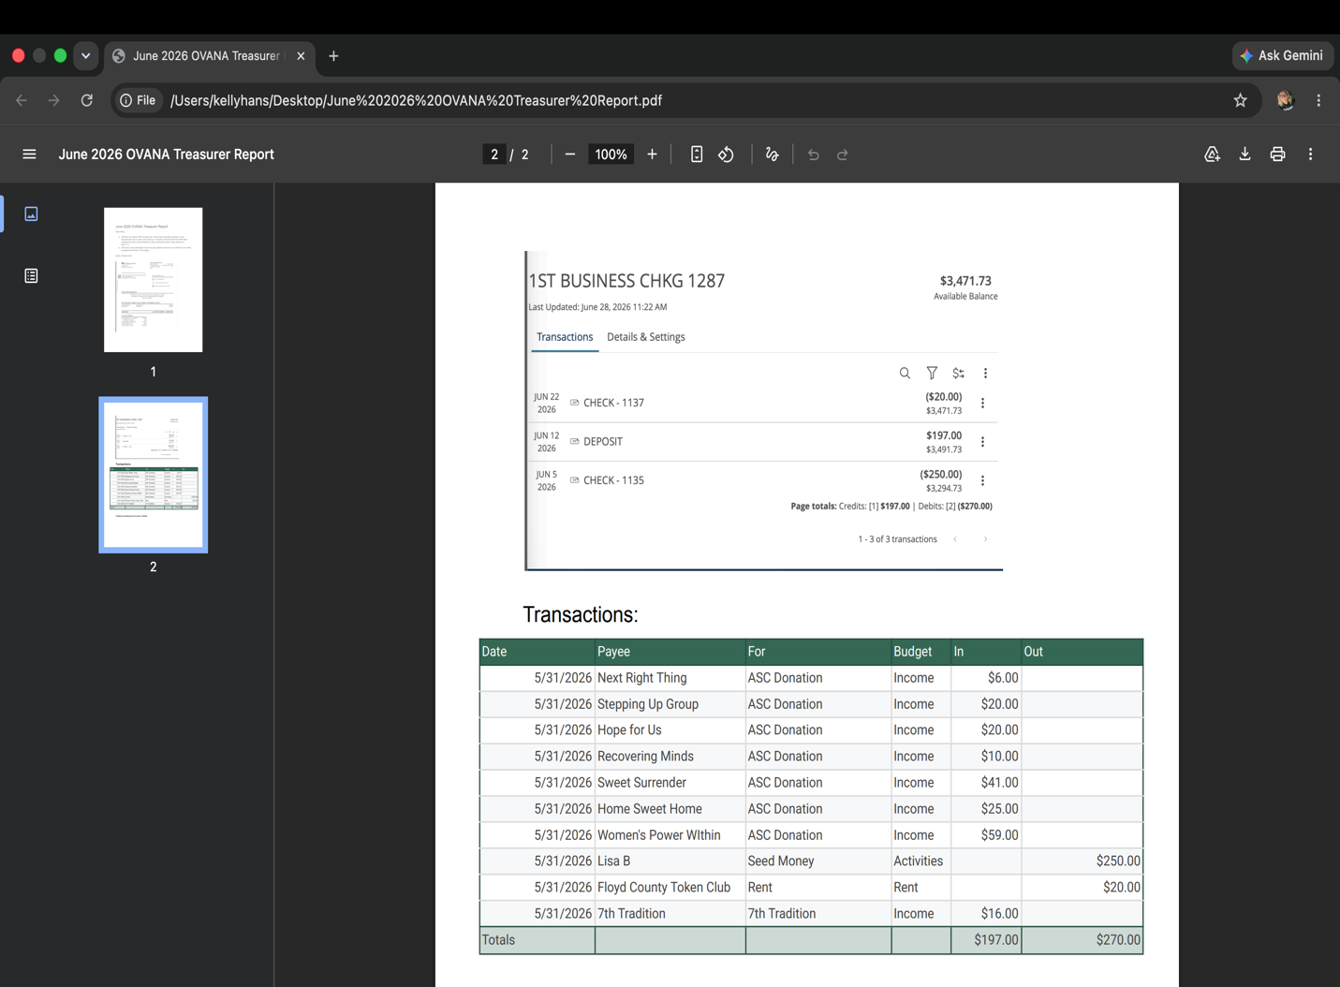

Literature

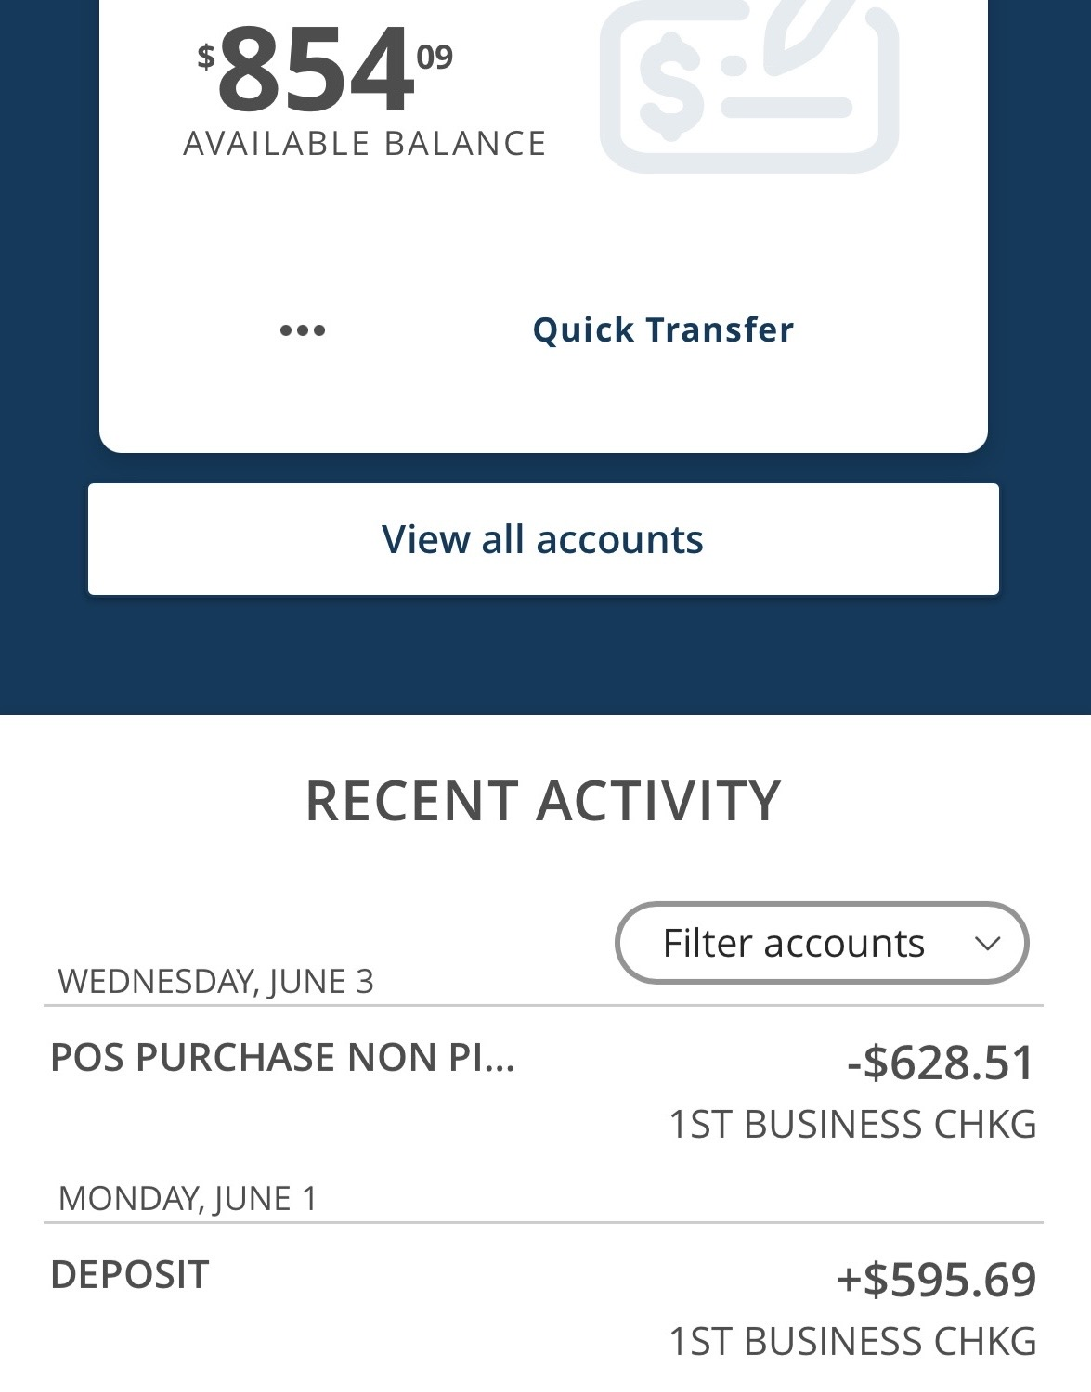
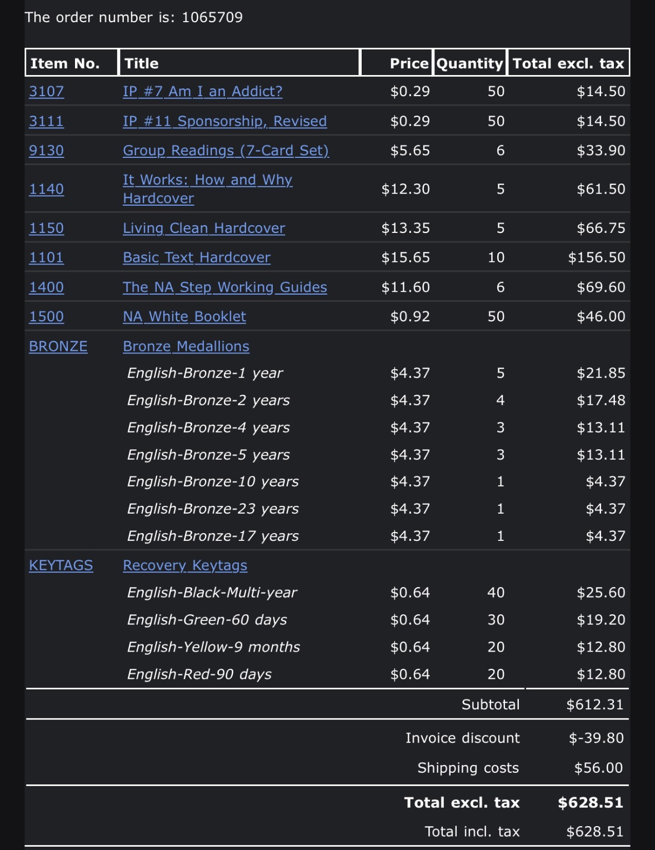

Service Resume
