OVANA ASC Monthly Meeting
Date: 8-30-26
Chair open the meeting @ 2p with the Serenity Prayer.
Any inexperienced GSR’s or Visitors.
Someone read 12 Traditions: Shea B. 12 Concepts: Joy F. Service Prayer: Kristin F
Roll Call
Service Position/Homegroup | Present | Absent
Chair – Kristin F | X
Vice Chair – Jason H. | X
Secretary – Open
Treasurer – Charlie W. | X
RCM – Joy F. | X
RCMA – Open
Literature – Erin W. | X
H&I – Shea B. | X
Activities – Lisa B.
Webmaster – Steve O. | Sent report
P&P – Open
Public Relations – Amanda A. | X
Home Sweet Home
Recovering Minds | X
Release the Control
Stepping Up Group | X
Sweet Surrender | X
The Next Right Thing | X
Women’s Power Within | X
Dope Or Us | X
KCB | X
Currently 9 home groups in OVANA with voting status. Official Quorum is 5.
Last month’s minutes read by: Jason H Any Corrections? No
Motion to Accept: Recovering Minds (Shea) 2nd: KCB (Joy)
All in Favor: X Opposed:0 Abstain:0
Subcommittee Reports
Chair: No Report
Vice Chair: No Report
Secretary: No Report
Treasurer: August 2026 OVANA Treasurer Report
Hello family,

- We had a net gain of $155 at July area bringing our current bank balance to $3210.73
- I forgot to mail the check for meeting schedules that was in the transactions at the July area, a new one will be written at August area for the total amount of all owed money and will tear up the old one and send the new one to the LASCNA PO box promptly
Bank Statement
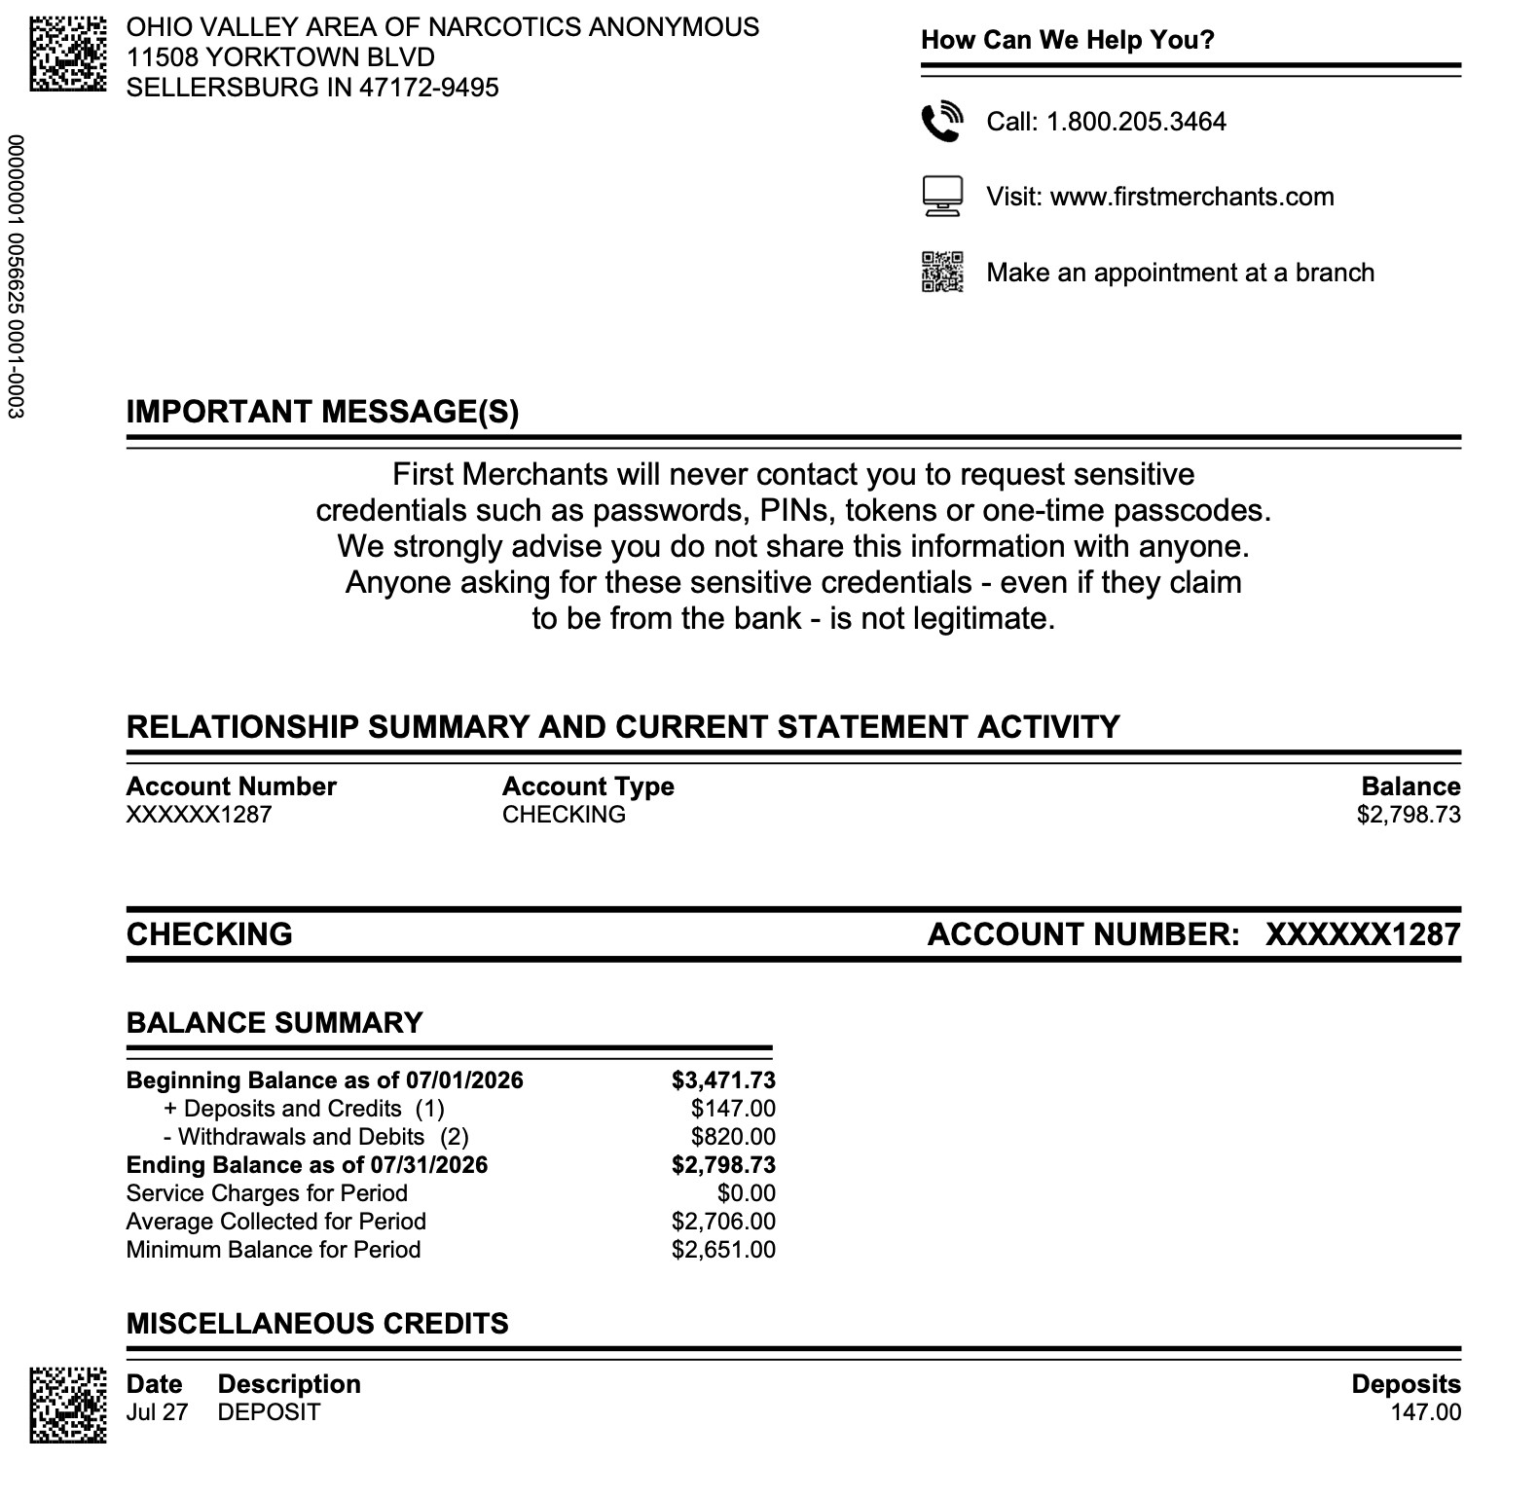
Transactions:
Date |  | Payee | For | Budget | In | Out
 | 7/26/2026 | Next Right Thing | ASC Donation | Income | $42.00
 | 7/26/2026 | Women's Power Within | ASC Donation | Income | $63.00
 | 7/26/2026 | Recovering Minds | ASC Donation | Income | $10.00
 | 7/27/2026 | Hope for Us | ASC Donation | Income | $20.00
 | 7/28/2026 | 7th Trad | 7th Tradition | Income | $20.00
Totals |  |  |  |  | $155.00 |  | $0.00

Thanks for allowing me to serve, Charlie

Motion to accept: The Next Right Thing (Yolanda) 2nd: WPW (Autumn
All in favor: X Opposed:0 Abstain:0

Literature:
Dear OVANA,

Here is the current literature account I formation. This balance includes a deposit made after August’s ASC.

Balance: $1, 089.15
Deposit on 7/7: $376.82
Deposit on 8/30 $270.44

No literature order was made in August.

Concerning the $200 OVANA to be used for H&I, $44 is remaining. The $100 for PR is still available.

In Loving Service
Erin W

Motion to accept: Sweet Surrender (Charlie) 2nd:Dope or Us (Nevada)
All in favor:X Opposed:0 Abstain:0
RCM: KRCNA 41 is upon us, OVANA will need to make a decision if we are ready.
RCMA: Open
H&I: Meets 1pm September 27th upstairs at Floyd County Token Club just before area. H&I needs trusted servants to chair meetings.
Activities: 8-30-26 Miracle in the Hills was a huge success. Attendees from various locations. $800.00 seed money will be returned + $243.00 for KRCNA fundraiser Date in November???

Webmaster: Hello Family-i am traveling and will not be at Area. The website is running fine, July Minutes have been uploaded. Please continue to send schedule changes, announcements and any other needed updates.
In loving and grateful service,
Steve O.

P&P: Open
PR: Amanda A will be having the PR subcommittee meeting upstairs at the Floyd Countyu Token Club @ 1pm September 27th. PR needs committee members.
Homegroup Reports
Home Sweet Home: Sean W. 1 year Sep 9th ; Tommy O. 3 years Sep 12th Shane L. 6 years and Charlie R. 29 years Sep 26th
Recovering Minds: no report

Release the Control: Absent

Stepping Up Group: we are formally requesting experience strength and hope on or meeting space. We have recently had our 1 year HG celebration posters removed do to another 12 step fellowship. We request experienced members attend to help grow our meeting.

Sweet Surrender: no report

The Next Right Thing: no report

Women’s Power Within: Tiffany M. 22 years Sep 21

Dope Or Us: no report

KCB: KCB would like to request literature for the new meeting. We would like basic texts and keytags. We have readings and pamphlets.

Nominations and Elections of New Officers
Open Position | Yes | No | Abstain
RCMA
P&P
Secretary
The above positions still need filled.
Motion to Nominate: 2nd:
Regional Motions
Regional Motion | Yes | No | Abstain
Open Forum
Old Business
New Business:
KCB wants to put a cap on KRSCNA treasurer’s account. Currently carrying a 20000-dollar balance.

KRCNA 41 OVANA is next in line to host unless we pass.

Next Area Business Meeting: September, 27th @ 2pm upstairs at the Floyd County Token Club
Close the meeting @ _2:45PM__ with Serenity Prayer

